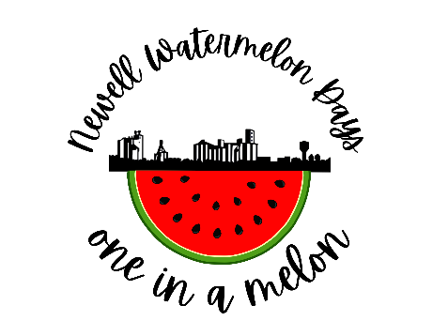
VENDOR APPLICATION
August 4-5, 2023

*Electricity is limited

ORGANIZATION NAME
CONTACT PERSON
MAILING ADDRESS
CITY, STATE, ZIP
PHONE #: |  | FAX#:
SALES TAX PERMIT # OR FED ID # OR SOCIAL SECURITY #

PRODUCTS OR SERVICE:
Type of item (food, beverage, or items) that your organization would like to sell. Please list your choices and approximate prices. If you plan to serve a meal, attach a menu, prices, and which meals that you plan to serve on a separate sheet. We will help advertise for you!

Items/Food/Drink for Sale (or attach menu/list with pricing): __________________________________________________________________________________________________________________________________________________________________________________________________
What Day(s) and hours do you plan to be open? Friday No Yes HOURS _____________
Saturday No Yes HOURS _____________
How much space do you need (size of trailer or table set-up)? ________________________________________________________________________________________________
Do you need electricity? No Yes If yes, how many watts? ________
Do you have a generator you can bring? No Yes If yes, is it loud? ______________
If you do not know the power consumption of all your equipment list them below:

List any preference of location. _____________________________________________________
List all hazardous materials that will be at your site (gasoline, propane, cleaning materials, etc.)

Signature, Title_____________________________________________________________________________________
Date ________________________________

APPLICATIONS ARE DUE JULY 21ST
Your application cannot be processed unless this form is completely filled out AND a copy of your proof of liability insurance coverage is enclosed.

