**Newell Municipal Golf Course**

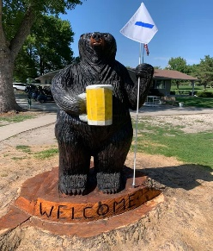**220 LeRoy Poulson Rd, Newell, IA 50568**

**Phone: 712.272.4424**

[Golfcoursemgr@newelliowa.com](mailto:Golfcoursemgr@newelliowa.com)

**Green Fees**: $20 Weekday or $25 Weekend/Holiday

**Driving Range:** $3.00/Bucket

**Punch Card**: 10 green fees for $150

**Membership**: $470 Family **($445 Early Bird before May 1**) $350 Single (**$325 Early Bird**) $95 Youth/College

\*\*\***\*Includes IOWA Golf Reciprocal**

* If Fonda member, pay $140/family & $100/single For Newell Membership
* Does **NOT** include Reciprocal program

**Cart Rental**: $12/9 holes $22/18 holes $30/all day

**Cart Shed Rental**: $150/Gas $175/Electric

**2022 Public Tournaments**

Payment (cash or check) due at registration in advance for all tournaments.

|  |  |
| --- | --- |
| May 29 (Sunday) | Memorial Day 4-Person 8” Cup Best Shot 18 Holes (9 am shotgun) |
| June 4 (Saturday) | Open Couples 2-ball 18 holes (9 am shotgun) |
| June 17 (Friday) | Fire Department 4-person Best Shot 18 holes  (9 am shotgun) |
| July 19 (Tuesday) | Women’s 4-gal Best Ball 9 holes (5:30 pm shotgun) |
| August 7 (Sunday) | Newell Watermelon Days 4-Person 18 holes  (10 am shotgun) |
| August 14 (Sunday) | Men’s Open – all day |
| August 27 (Saturday) | Allee Mansion 2 couple scrabble 4/team 1 lady/team (10 am shotgun – 18 holes) |
| September 11(Sunday) | 4-Person 8” Cup Best Shot 18 holes (10 am shotgun) |
| September 24 (Saturday) | Glowball 4-Person 9 holes (shotgun at dusk: around 7:45pm) |